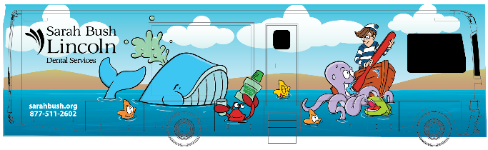
LEAVE GARAGE
- Inspect outside of bus and bus garage, to be sure it is safe to pull out of garage
- Unfold Stairs
- Unlock Door
- Enter bus
- Turn on generator
- Turn power switch to OFF, then unplug shore power. Unplug network cables.
- Perform Daily inspection checklist.
- Run Biological tests.
- Retrieve needed items from under-bus storage for restocking.
- Check all cabinets and drawers to be sure they are placed in the LOCK position.
- Be sure pins are secured in PANO
- Close stairs when ready to leave.
- Be sure everyone who is traveling has seat belt.
- Back out of garage.
- Close garage door.
- Read Daily Charge as traveling.

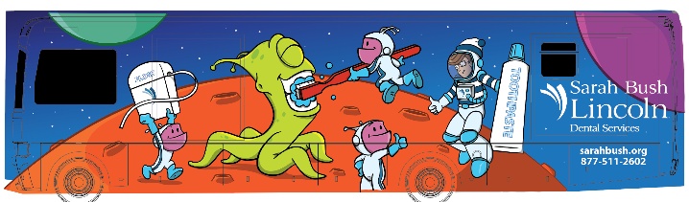
RETURN TO GARAGE

- Park near dump tank, outside garage, if required.
- Follow dump/fill schedule.
- Open Garage Door, pull into garage
- Open stairs
- Inspect outside of bus to be sure you have clearance for slide outs (if needed)
- Make a list of items that are needed for restocking
- Follow cleaning schedule (extend slide outs if cleaning schedule requires it.)
- Confirm last load of sterilization is complete. Prepare to bring remaining instruments to clinic or SPD as needed.
- Remove trash
- Exchange any nitrous or oxygen tanks as needed.
- Refill DEF as needed (if not filled while refueling).
- Be sure shore power is in the OFF position, plug in, then flip switch to ON.
- Plug into network.
- Post trip inspection. Headlights off
- Note: Badger vacuums have a 10 minute auto cycle at end of day.
- Return slide outs to closed position.
- Turn generator off.
- Lock Door
- Be sure garage lights are off and close garage door.

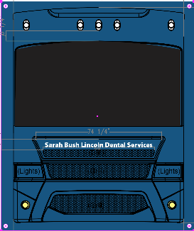

ARRIVE AT CLINIC or SCHOOL LOCATION

- Confirm parking Spot
- Park Bus
- Emergency Brake
- Lower Stairs
- Inspect outside of bus to be sure there is enough clearance for stairs and slide outs
- Release air suspension switch.
- Lower Jacks
- Extend Slide outs
- Have assigned person meet with school regarding plans for the day while this checklist is being administered. Bring Walkie Talkie.
- Untie chairs.
- Turn on computers, Open Dental, MiPacs, etc.
- Turn on PANO, remove pins and prepare for use.
- Turn on vacuums, Air Compressor, Water Heater
- Set up operatories
- Set up sterilization, start biological tests if not already started.

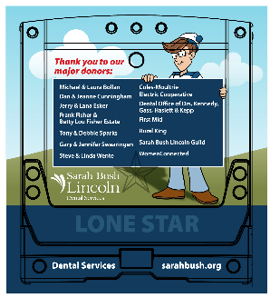

DEPART FROM CLINIC or SCHOOL LOCATION

- Have designated person check in with school and give a report. Ask how things went from their perspective. Collect Walkie Talkie.
- Finish last load of sterilization.
- Shut down software, PANO, Air Compressor, vacuums, water heater, computers and place ERGOTRON in upright position.
- Replace pins to secure PANO.
- Secure all loose items on counters.
- Check all cabinets and drawers to be sure they are placed in LOCK position.
- Tie down equipment and chairs.
- Be sure nitrous cart is tied down and tanks are closed.
- Be sure all outside compartments are closed.
- Retract slide ins. Be sure nothing is in the way of slide out and there is no debris on floors.
- Be sure everything in sterilization area is put away and properly stored/tied down.
- Raise jacks
- Raise stairs
- Be sure everyone is secure in a seat belt.
- Release Emergency Brake
- Pull away from curb/ parking space.
- Check diesel fuel levels, stop to refuel if necessary. Try to fill when half full. Fill DEF as needed.
- Work on paperwork on way back to garage.

