Spaghetti Diagram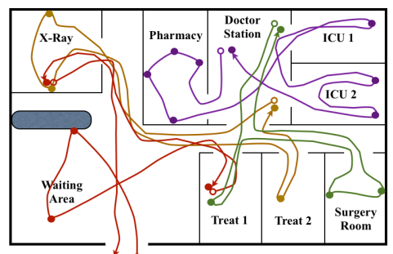

A spaghetti diagram (a Lean Principle) is a visual representation of the flow of people, materials, or information within a process, showing the path taken by an item or activity through a system. It's called a spaghetti diagram because the lines tracing the path often look like a messy plate of spaghetti. You can find inefficiencies and lots of repetitive motion. This can help you look at your process and find ways to simplify or move things to simplify the process.
For a team activity, try following a patient through your system…. Is there a better way to bring them through your bus or fixed site? Are they backtracking a lot. Look at it “through the patient’s eyes” Then you can follow your provider, your nurse, etc. to determine ways to improve how people move through your process.
This is a tool we used to redesign our workflow and add a 4th operatory to our fixed site, which allowed us to see more patients and reduce wait times for appointments. Without adding any staff members.

